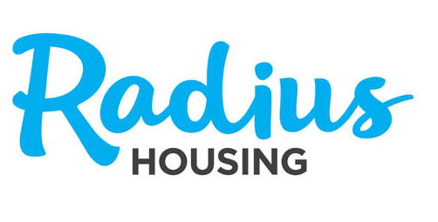
Woodbrook, Omagh
12 CAT1/over 55s apartments

Proposed Scheme: New Social Housing Development in Woodbrook
Location: Lands within Woodbrook Village, Omagh (see map overleaf)

Housing Mix: 12 x 3 Person 2 Bedroom CAT1 (over 55s) apartments
for social rent

Development Proposals:

The development proposals were recently approved by Omagh & Fermanagh District Council under Planning Application Reference Number LA10/2018/0052/F and LA10/2020/0950/NMC. Construction is due to commence on site in early 2021 and it is anticipated the properties will be completed in mid 2022.
Radius intends to purchase the properties upon completion from the developer, Bayswater Homes Ltd, to provide 12 social rent apartments for over 55 year olds. This will help to meet the growing demand on the Northern Ireland Housing Executive waiting list for the Omagh area.

Feedback and Comments:
Have a look at the development proposals on Radius Housing’s website: www.radiushousing.org/developments.coming-soon
Due to COVID-19, we will unfortunately be unable to organise a public community consultation event. However we would welcome your comments or feedback.

Layout and Elevations
Please see details of the layout and elevations overleaf

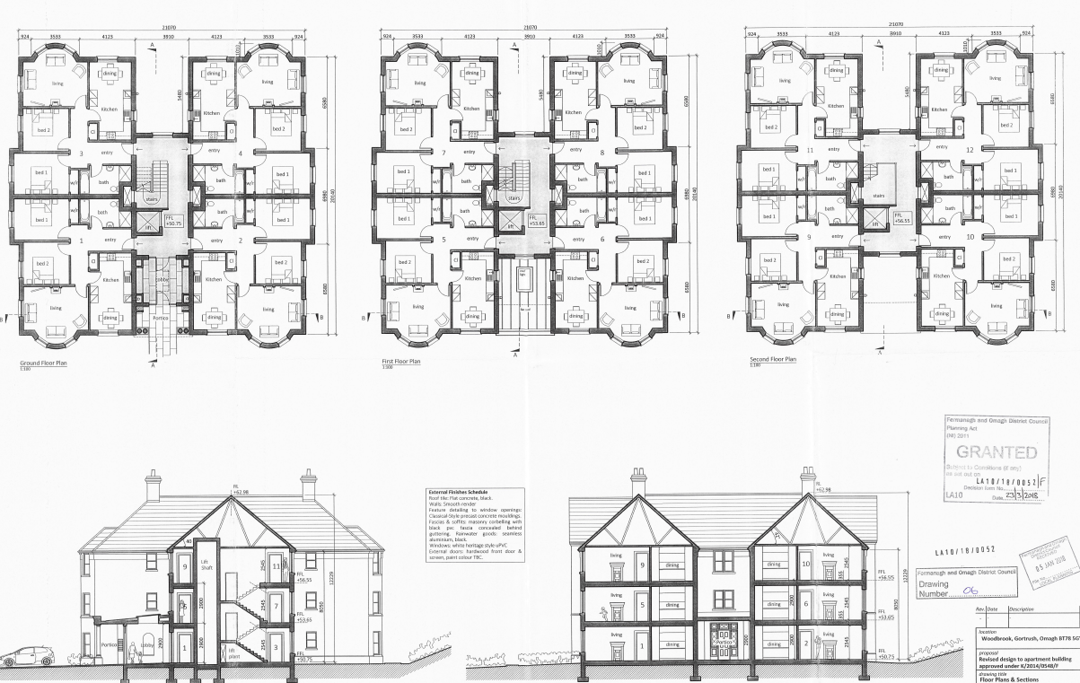
Location plan
